SNOOZE — AI POWERED ETHICAL FASHION DISCOVERY

A PROJECT REPORT
BY
TEAM NO. 4

Aarushi Goel (E23CSEU1097)
Akshita Parashar (E23CSEU1100)

Sowmya Negi (E23CSEU1102)

SUBMITTED TO

SCHOOL OF COMPUTER SCIENCE ENGINEERING AND TECHNOLOGY, BENNETT UNIVERSITY
GREATER NOIDA, 201310, UTTAR PRADESH, INDIA

April 2025

DECLARATION

We hereby declare that the work which is being presented in the report entitled “SNOOZE — AI POWERED ETHICAL FASHION DISCOVERY”, is an authentic record of our own work carried out during the period from JAN, 2025 to APRIL, 2025 at School of Computer Science and Engineering and Technology, Bennett University, Greater Noida.
The matters and the results presented in this report have not been submitted by me/us for the award of any other degree elsewhere.

Signature of Candidate

Aarushi Goel
(Enroll. No. E23CSEU1097)

Akshita Parashar
(Enroll.No.E23CSEU1100)

Sowmya Negi
(Enroll. No. E23CSEU1102)

ACKNOWLEDGEMENT

We would like to take this opportunity to express our deepest gratitude to our mentors, Ms. Shashi Shreya(Assistant Professor), Ms. Garima Jaiswal and Ms. Bhawana for guiding, supporting, and helping us in every possible way. We were extremely fortunate to have them as our mentors as they provided insightful solutions to problems faced by us thus contributing immensely towards the completion of this capstone project. We would also like to express our deepest gratitude to VC, DEAN, HOD, faculty members and friends who helped us in successful completion of this capstone project. Any other name you can mentioned here.

Signature of Candidate

Aarushi Goel
(Enroll. No. E23CSEU1097)

Akshita Parashar
(Enroll. No. E23CSEU1100)

Sowmya Negi
(Enroll. No. E23CSEU1102)

TABLE OF CONTENTS
LIST OF TABLES vi
LIST OF FIGURES vii
LIST OF ABBREVIATIONS viii
ABSTRACT ix
1. INTRODUCTION 1
1.1. Problem Statement 1
2. Background Research 2
2.1. Proposed System 2
2.2. Goals and Objectives 2
3. Project Planning 3
3.1. Project Lifecycle 3
3.2. Project Setup 3
3.3. Stakeholders 4
3.4. Project Resources 4
3.5. Assumptions 5
4. Project Tracking 5
4.1. Tracking 5
4.2. Communication Plan 6
4.3. Deliverables 7
5. SYSTEM ANALYSIS AND DESIGN 8
5.1. Overall Description 8
5.2. Users and Roles 8
5.3. Design diagrams/ UML diagrams/ Flow Charts/ E-R diagrams 9
5.3.1. Use Case Diagrams 9
5.3.2. Class Diagram 10
5.3.3. Activity Diagrams 11
5.3.4. Sequence Diagram 12
5.3.5. Data Architecture 13
6. User Interface 14
6.1. UI Description 14
6.2. UI Mockup 14
7. Algorithms/Pseudo Code 15
8. Project Closure 16
8.1. Goals / Vision 16
8.2. Delivered Solution 16
8.3. Remaining Work 16
REFERENCES 17

LIST OF TABLES
Table Page
Table 1: Goal and Objectives 2
Table 2: Sample 2 3
Table 3: Sample 3 4
Table 4: Sample 4 4
Table 5: Sample 4 5
Table 6: Sample 6 5
Table 7: Regularly Scheduled Meetings 6
Table 8: Information To Be Shared Within Our Group 6
Table 9: Information To Be Provided To Other Groups 6
Table 10: Information Needed From Other Groups 7
Table 11: Deliverables 7
Table 12: Sample 12 8

LIST OF FIGURES
Figure Page
Figure 1: Sample use-case diagram 9
Figure 2: sample 2 11
Figure 3: sample 3 12
Figure 4: Sample 4 13
Figure 5: Sample 5 13
Figure 6: Sample 6 14

LIST OF ABBREVIATIONS
Abbreviation Explanation of the Abbreviation
AAA Authentication Authorization and Access Control
CSP Cloud Service Provider
DNS Domain Name System
IAM Identity and Access Management

ABSTRACT
The fashion world is changing at a very fast rate, and yet shoppers tend to remain deprived of products that suit their special tastes and needs in a fast fashion-overloaded market. Small and niche fashion retailers with innovative or bespoke designs find it difficult to gain prominence in mainstream online shopping websites. SNOOZE, an AI-driven platform, this project suggests, can fill this void by offering intelligent and personalized fashion discovery experiences. The platform curates fashion items from emerging and small brands, providing consumers with an easy and visually dense means of browsing styles that are relevant to them.

SNOOZE employs sophisticated AI methods like collaborative filtering, content-based recommendation models, and deep learning for image and text processing. It allows natural language requests (e.g., "I need a red satin prom dress with a high slit") and image-based searches (e.g., posting a photo of a dress), making it simpler for users to retrieve visually and contextually similar products. The system relies on high-level product features, visual representations from convolutional neural networks, and vector-space text analysis (e.g., TF-IDF or transformer models) to identify matching user input with appropriate products.

The project entails the creation of a sophisticated, easy-to-use interface, a smart recommendation system, and strong multimodal search support. Beyond usability, the platform is designed to be scalable, future-proof, and collaborative with fashion sellers seeking to increase their online presence.

The value of this work is its ability to remake online fashion discovery as more personal, visual, and efficient. By giving smaller fashion brands greater visibility and smarter tools to allow consumers to navigate styles, SNOOZE remakes the online shopping experience through the filter of AI.

INTRODUCTION
The contemporary fashion market is growing at a fast pace with the emergence of online shopping platforms and fast fashion retailers. Although this has increased the availability of fashion, it has also resulted in a very competitive online space dominated by mass-market retailers. In such a space, small and independent fashion brands that provide distinctive, high-quality, or niche styles tend to find it difficult to receive the visibility they need.

Traditional online fashion discovery sites generally favour popular and low-price products, so it is challenging for consumers to browse differentiated styles or discover products highly in line with their individual tastes. This constrains the growth and penetration of new fashion companies and does not provide consumers with an authentic personalized and interactive shopping experience.

In order to solve this problem, SNOOZE — AI-Powered Fashion Discovery was envisaged as a sophisticated, intelligent platform that enables users to discover exactly what they want with natural language input, image search, and intelligent recommendations. It enables small and new fashion brands by enhancing product discovery and enabling customers to discover fashion through intuitive AI-powered exploration tools.

Trending Topics Impacting This Project:
- Emergence of AI-based recommendation engines in online shopping.

- Growing interest in customized and visually-oriented shopping experiences.

- Emergence of niche and independent fashion brands venturing into the digital space.

- Demand for intelligent, multi-modal product discovery tools capable of text and image input.
  - Problem Statement
Most of today's fashion discovery and shopping sites are oriented towards showcasing big brands of fast fashion, with small labels or independent labels having minimal opportunity to emerge. Shoppers are frequently frustrated when attempting to locate products that fit certain styles, aesthetics, or design aspects — particularly when using only basic keyword searches or navigating generic categories.

There is a definite shortage of AI-based platforms that integrate visual comprehension, natural language processing, and individualized recommendation platforms to provide an authentic intuitiveness in fashion discovery. This shortcoming impacts both:

Small fashion companies, which cannot reach broader digital audiences.

Fashion-forward consumers, who prefer smarter and more targeted means of searching for goods online.

SNOOZE strives to fill this void through the development of a solid AI-driven fashion discovery platform that provides consumers with advanced instruments to browse items via text descriptions, image uploads, and context-based recommendations. It improves discoverability for small brands and rediscovers online shopping as a highly personalized, smart experience.
- Background Research
Over the last few years, the world fashion industry has grown exponentially with e-commerce and fast fashion taking over. While growth has also introduced a highly saturated and competitive digital market space in which small and new fashion brands find it challenging to make an impact, customers are ever-more looking for different, expressive, and individual fashion experiences. The majority of digital platforms still just offer rudimentary filters and blanket search results.

Existing AI-driven technology such as ASOS Style Match and Amazon Visual Search is more focused on convenience and price, providing minimal support for sensitive, style-driven searches. While those platforms addressing niche or independent fashion brands are deprived of sophisticated AI features that can customize and intelligently navigate the user journey.

A study by Jannach et al. (2021) illustrates how recommendation systems powered by AI can raise customer interaction up to 30%. However, there is a lack of platforms that leverage these methods to support users in visually and textually driven discovery of fashion — particularly in supporting smaller labels to make their presence known.

These findings led to the conception of SNOOZE: an intelligent, AI-based fashion discovery site that assists users in discovering clothing and accessories that fit their look and purpose requirements, as well as enhancing the visibility of small and independent fashion brands.

  - Proposed System
The SNOOZE project suggests the creation of an AI-driven, web-based fashion discovery platform that aims to make the search for fashion products easier through a visual-first and personalized experience. The platform will feature fashion products from small and rising fashion brands, allowing users to discover a variety of styles through smart search and recommendation systems.
The platform will feature:
- Natural language search, in which users can enter descriptions such as "flowy white dress with lace detail."
- Image-based search, allowing users to upload a photo and find visually similar items.
AI-driven recommendations, using collaborative filtering and content-based models to adapt to user preferences over time.

The objective is to increase fashion discoverability beyond simple filtering by providing an enriched, multi-modal search experience that knows both what the user is looking for and how it should appear. The architecture of the system will focus on scalability and flexibility in order to integrate new AI models, product types, and user information.
Through the integration of natural search with state-of-the-art AI models, SNOOZE sets out to reinvent user interactions with online fashion in a frictionless experience that not only aids in product discovery but also boosts small fashion companies within the online market.
Table 1: Goal and Objectives
# | Goal or Objective
1 | Develop an AI-powered fashion discovery platform focused on fashion products that match your taste.
2 | Improve the online discoverability of fashion brands.
3 | Discourage doom scrolling by content-based filtering.
4 | Ensure the system is extensible and scalable for future feature additions and brand partnerships.
5 | Have fun and foster teamwork while working on the project.

- Project Planning
This section outlines the overall development process, project stakeholders, required resources, and assumptions for the Snooze project — an AI-powered fashion discovery platform. The project will follow an Agile-based lifecycle with SCRUM-like iterations, ensuring flexibility, continuous feedback, and iterative improvements. Key stakeholders have been identified, including the core team, faculty mentor, target users, and peer reviewers. Essential resources like development tools, datasets, and AI frameworks have been planned in advance. Certain assumptions regarding the availability of ethical fashion product data and the technical feasibility of AI-powered product search have been made to guide the project's execution effectively.

  - Project Lifecycle
The team will follow an Agile development approach for the Snooze project. Requirements will be gathered at the start and a high-level development plan will be created. The implementation will be carried out over three iterative sprints, allowing for continuous feedback, improvement, and adjustments. The team will adopt a SCRUM-like framework, emphasizing frequent team meetings, collaborative decision-making, and active stakeholder involvement to keep the project aligned with its objectives and user needs..
  - Project Setup

Table 2: Decision Description
# | Decision Description
1 | Use Python for AI model development and Streamlit for building the prototype user interface.
2 | Use Google Colab for collaborative AI model training, testing, and iteration.
3 | Source product discovery datasets from fashion brand listings and supplement with simulated data for testing purposes.
4 | Assumption: Clean, structured product metadata will be available from companies

  - Stakeholders
Table 3
Roles
Stakeholder | Role
Fashion Retailer | Brands listed or partnered on the platform
Ms. Shashi Shreya | Supervision, technical guidance, and reviews
Fashion Consumers | End users of the platform and onboarding brands
Akshita Parashar | Designing, developing, and testing the platform
Aarushi Goel | Designing, developing, and testing the platform
Sowmya Negi | Designing, developing, and testing the platform

  - Project Resource
Table 4: Resource description
Resource | Resource Description | Quantity
Google Colab | Cloud-based collaborative environment for AI model development and testing | 1
Development Team | Core developers and project managers | 3
Faculty Guide | Ms. Shashi Shreya— provides project supervision and technical guidance | 1
Fashion Dataset | Open-source and simulated datasets of fashion product listings | 1
Test Users | fashion consumers and students providing usability feedback | 20

  - Assumptions

Table 5: Assumption
# | Assumption
A1 | The SNOOZE team will be able to meet with mentors weekly to discuss progress and feedback.
A2 | AI tools and platforms, such as Azure ML or other suitable alternatives, will be available for use throughout the project.
A3 | The team will have sufficient time to complete the AI-powered recommendation engine and platform by the project's deadline.
A4 | Fashion brands will be willing to provide data or collaborate in showcasing their products on the platform.
A5 | Data collected on fashion will be sufficient for training the AI recommendation models.
A6 | The platform’s AI models will be scalable and adaptable to include more brands and product categories in the future.

- Project Tracking
  - Tracking

Table 6: Description
Information | Description | Link
Code Storage | Project code will be stored in GitHub repository. | Link
Bug Tracking | Bug tracking will be done with Git. | Link
Project Documents and Assignments | Weekly reports through Microsoft Forms, specification and design documents, etc. will be stored in our Git repository. | Link
Continuous Integration | Continuous integration will be done with Jenkins. | Link
Regression Testing | Regression testing will use Google Colab | Link

  - Communication Plan
Table 7: Regularly Scheduled Meetings
Meeting Type | Frequency/Schedule | Who Attends
Conference Call | Weekly | Project team
Team Meeting | Weekly | Project team
Short Meeting | Weekly in class | Project team
Sprint Planning Meeting | Start of each sprint | Project team and mentor
Sprint Retrospective Meeting | End of each sprint | Project team
Sprint Review Meeting | End of each sprint | Project team
Table 8: Information To Be Shared Within Our Group
Who? | What Information? | When? | How?
Project team | Task assignments & General scrum information | Weekly | Team meetings, listing in Project Specification.

Table 9: Information To Be Provided To Other Groups
Who? | What Information? | When? | How?
Admin users | Project Demo, Testing | At completion of project | Live demo
Sponsor and mentor | Weekly report | Weekly | Email and Trac site access

Table 10: Information Needed From Other Groups
Who? | What Information? | When? | How?
Mentor | Requirement changes | Start of each sprint | Conference call or meeting with sponsor and mentor.

  - Deliverables

Table 11: Deliverables
# | Deliverable
1 | Project Report
2 | Source code for SNOOZE, including AI models and UI components.
3 | Admin and student interfaces
4 | Working web application
5 | Final Presentation Slides
6 | Tests Reports and feedback Summary
7 | Final report (final PowerPoint presentation, 3 minute video, and final sprint)

- SYSTEM ANALYSIS AND DESIGN
  - Overall Description
This project, named SNOOZE, is a fashion discovery platform that uses AI to assist small and independent fashion brands in achieving digital visibility, while providing consumers with a highly intuitive and personalized means of discovering products that fit their individual tastes. The site curates fashion products from a wide variety of up-and-coming brands and uses sophisticated artificial intelligence methods to suggest products according to users' style, natural language search, image upload, and browsing history. In contrast to traditional e-commerce platforms that use generic filters or push fast fashion trends, SNOOZE redefines product discovery using intelligent algorithms that comprehend the aesthetic, contextual, and visual aspects of fashion.
The SNOOZE system architecture consists of a number of combined components: a product aggregation module that gathers data from websites and platforms of multiple brands through APIs and web scraping; a user profiling system that monitors user behaviour and user preferences; and a strong AI-based recommendation engine that combines collaborative filtering, content-based filtering, and vision models. The data gathered is comprised of product images, product descriptions, brand metadata, material types, and prices. This augmented dataset is utilized to train models providing precise, style-sensitive suggestions in accord with user inputs and visual indications.
SNOOZE provides enhanced capabilities including:

- Text-based search ("long red evening dress with back slit")
- Image-based search (upload an image to locate similar styles)
The technical process starts with data acquisition and preprocessing via Python-based platforms, then model training through libraries like Scikit-learn, TensorFlow, and OpenCV for image processing. Both the classification and similarity models are compared for precision in modelling fashion-related features. The end-platform has a smooth front-end developed with contemporary web frameworks and is deployed on flexible cloud infrastructure to cope with large-scale data and real-time recommendations. Using SNOOZE, the project envisions revolutionizing the way users browse fashion on the internet—enabling discovery by smart AI tools and enabling small brands to reach style-conscious consumers more efficiently.

Top of Form
Bottom of Form
Table 12: Key User Roles and Responsibilities
User | Description
Developer | A capstone team member or mentor who is tasked with managing the test data, creating initial machine learning models, and ultimately generating a firm process for applying these techniques to future user data..
Project Mentor | Provides guidance on AI implementation strategies, fashion market insights, and validates the technical and business decisions taken by the team during development.
End User (Consumer) | A conscious fashion shopper using the SNOOZE platform to discover and purchase fashion products based on personalized recommendations.

  - Design diagrams/Architecture/ UML diagrams/ Flow Charts/ E-R diagrams

    - Product Backlog Items
As a conscious shopper, I want to discover fashion brands that meet my requirement.
As a developer, I want to aggregate product data from multiple fashion brands so that I can build a diverse and rich product catalogue.
As a developer, I want to document the build, installation, and user processes so that future teams can maintain and scale the platform.
As a conscious shopper, I want to receive personalized product recommendations so that I can find items matching my style preferences.

    - Architecture Diagram
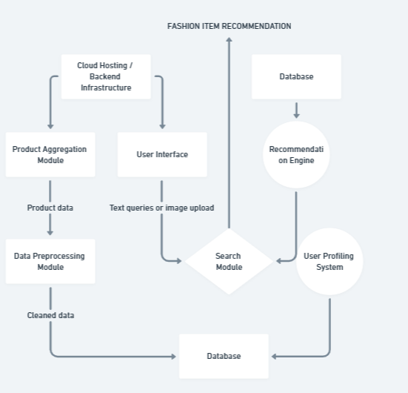
    - Use Case Diagram
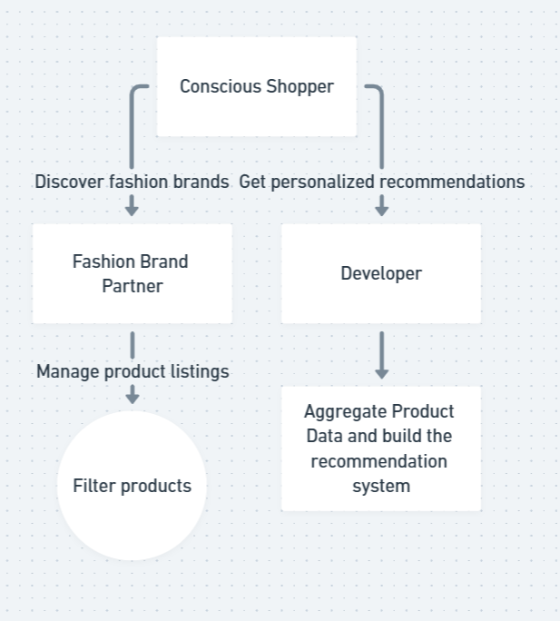

    - Class Diagram

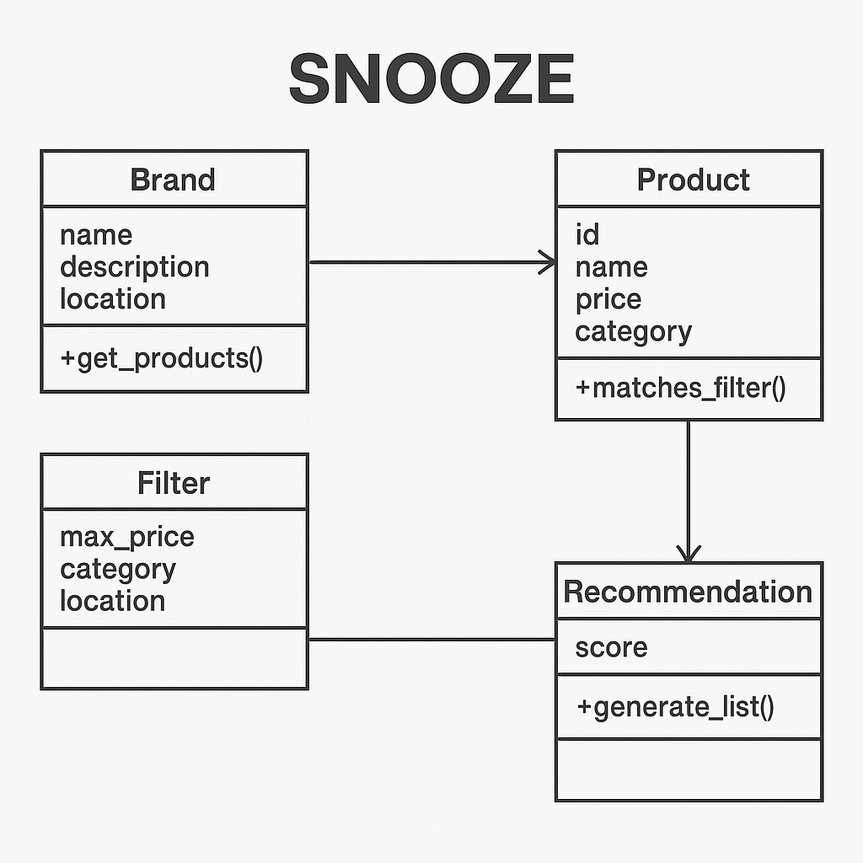
Figure 2: Algorithm of Snooze
    - Activity Diagrams
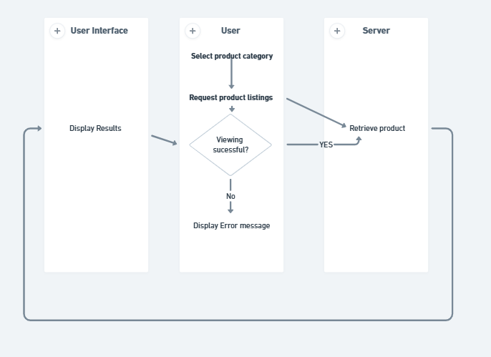
Figure 3: sample 3
    - Sequence Diagram
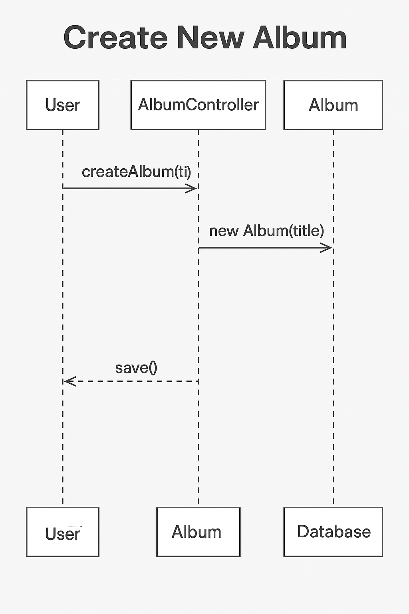
Figure 4: Sample 4
    - Data Architecture
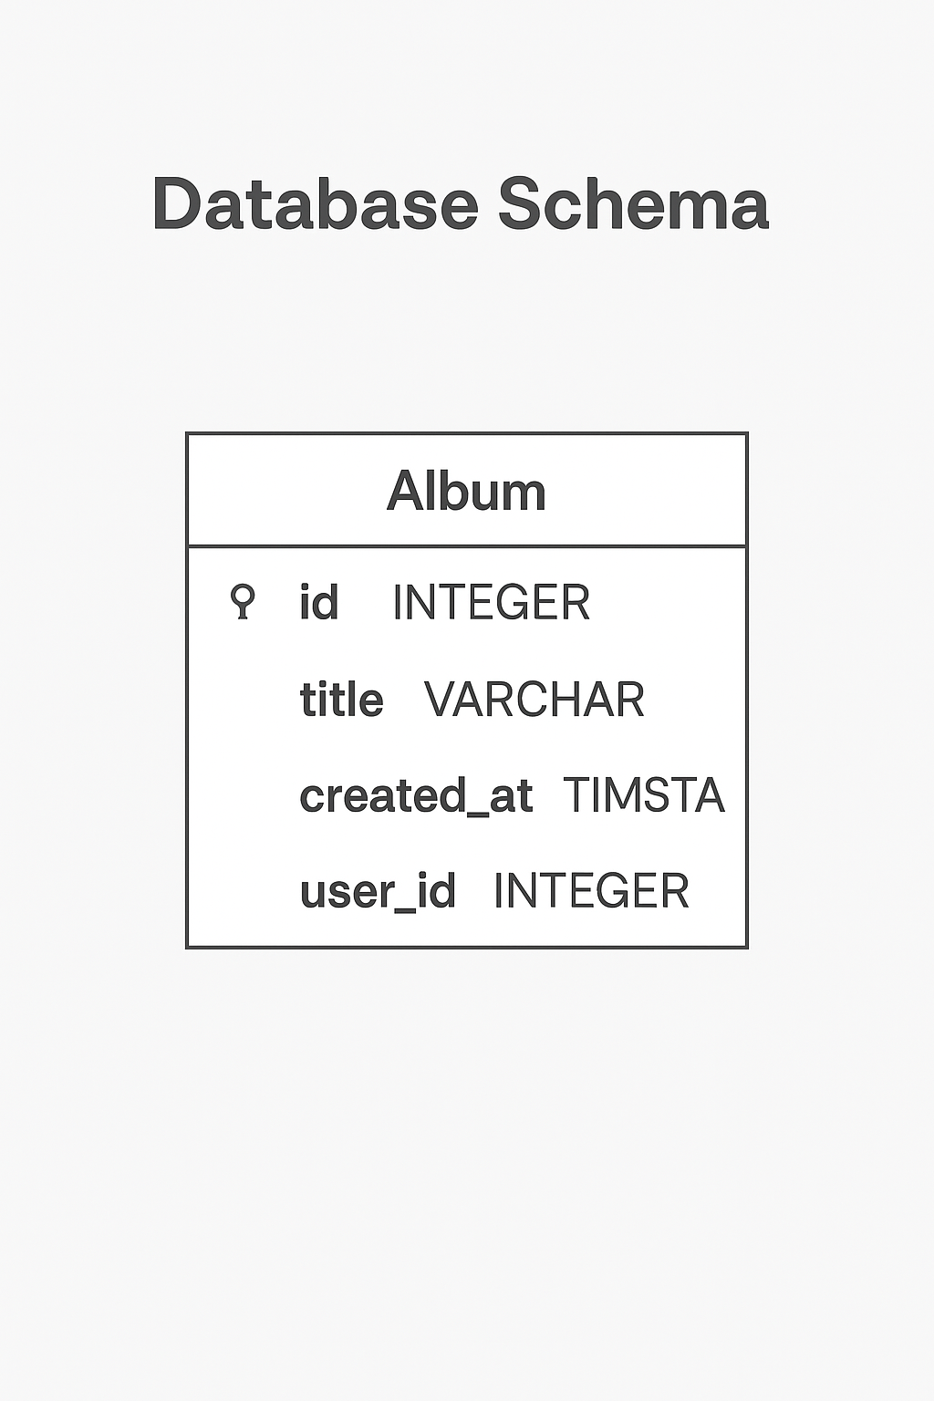
Figure 5: Sample 5

- User Interface
  - UI Description
The user interface for Snooze is designed to be intuitive, visually appealing, and easy to navigate for users with minimal technical experience. Built using tools like Figma, the UI focuses on simplicity and clarity while maintaining a fun and ethical brand identity.
The landing page prominently features product highlights, bestsellers, and a quick guide on how the platform works. A visual category-based "Shop by Outfit" gallery allows users to explore sustainable clothing options effortlessly.
The platform flow is user-centric — users can interact through basic buttons, filters, and AI-based search features. Once fully implemented, the design will support dynamic content rendering, product carousels, and a possible drag-and-drop image search in future iterations. The consistent colour palette and playful icons further reinforce brand identity and accessibility.
  - UI Mock-up
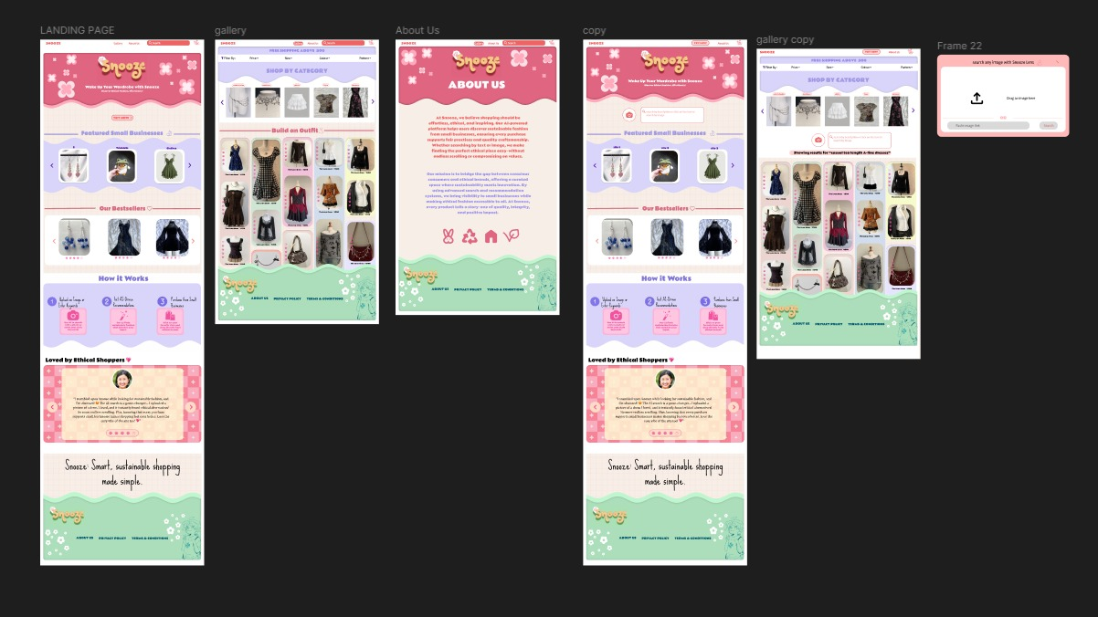

Figure 6: Sample 6

- Algorithms/Pseudo Code OF CORE FUNCTIONALITY
main.py

Import modules, load dataset

Take user input: text / image URL / color / filters

Use respective search engine

Apply filters if needed

Display final results

image_search.py

Preprocess image, extract ResNet50 features

Class ImageSearchEngine: store image features

search(): find top N similar images

text_search.py

Class TextSearchEngine: embed product texts

search(): compare query embedding via cosine similarity

color_search.py

Extract dominant color (KMeans)

Class ColorSearchEngine: store product colors

search(): find closest colors

filters.py

apply_filters(): filter DataFrame by conditions

data_preprocessing.py

load_and_clean_data(): load, clean, normalize, validate dataset

color_utils.py

Extract dominant color, RGB ↔ Hex, color distance

text_embedding.py

Embed text(s) via SentenceTransformer

test_search.py

Load data, test each search engine and filters
- Project Closure
  - Goals / Vision
Our initial aim was to develop SNOOZE, an AI-powered platform for discovering fashion brands with the aid of personalized recommendations. Throughout the duration of the project, we distilled our target towards emphasizing AI-supported product discoverability, visual search functionality, and content-based filtering that displays people only what they desire — so they do not have to browse endlessly through undesired products. In addition, we solidified our technical base by creating a scalable database schema, data pipelines, and recommendation models to make the platform extensible for future improvements.

  - Delivered Solution
Our preferred solution was to develop SNOOZE, an AI-powered platform for product discovery that gathers fashion items and offers tailored recommendations based on relevance. The goal of the initiative was to bridge the discoverability gap for consumers who want to quickly find products that suit their preferences without having to do a lot of scrolling in a crowded online store.
We have produced a live, AI-powered web platform with a simple user interface, sophisticated filtering tools for product discovery, and AI-powered recommendation systems tailored to individual preferences. A database schema, product data ingestion pipelines, and an ML module for generating tailored product recommendations make up the system. We also produced comprehensive project documentation, system diagrams, a final presentation of our work, and basic visual search and intelligent filtering capabilities.

  - Remaining Work
Future enhancements will focus on improving model precision, expanding the dataset for better generalization, implementing additional filtering options (e.g., price, brand), and integrating a comprehensive user feedback system to continuously refine recommendations.
REFERENCES
1.T. Dillon, C. Wu, and E. Chang, “Cloud Computing: Issues and Challenges,” in 24th IEEE International Conference on Advanced Information Networking and Applications, pp. 27-33, 2010.

2.⁠ ⁠H. Casanova et al., “Heuristic for Scheduling Parameters Sweep Applications in Grid Environments,” in Proceedings of the 9th Heterogeneous Computing Workshop, HCW, 2009.

3.⁠ ⁠Kwok, Yu-Kwong, and Ishfaq Ahmad, “Static Scheduling Algorithms for Allocating Directed Task Graphs to Multiprocessors,” ACM Computing Surveys, vol. 31, no. 4, pp. 406-471, 1999.

4.⁠ ⁠A. Mutz and R. Wolski, “Efficient Auction-Based Grid Reservation Using Dynamic Programming,” in IEEE/ACM Int’l Conf. on Super Computing, SC 2007.

5.⁠ ⁠Additional literature on content-based image retrieval and CNN-based feature extraction (details available in our research library).

APPENDICES

• Appendix A: Design Diagrams (Use Case, Class, Activity, Sequence, Data Architecture)

• Appendix B: Weekly Progress Diary
- Week 1–8: Detailed progress logs (research, dataset collection, model development, API integration, UI design, testing, and deployment)
- Week 9–12: Refinements, additional feature enhancements, final testing, and deployment details

• Appendix C: User Feedback and Iterative Improvements
- Summarized feedback collected from potential users and senior batch students, along with actions taken

